EdTech Extension Installation Guide

1. Download the zip file of the extension.

2. Unzip the file into a folder.

3. Go to Chrome and click on the puzzle icon.

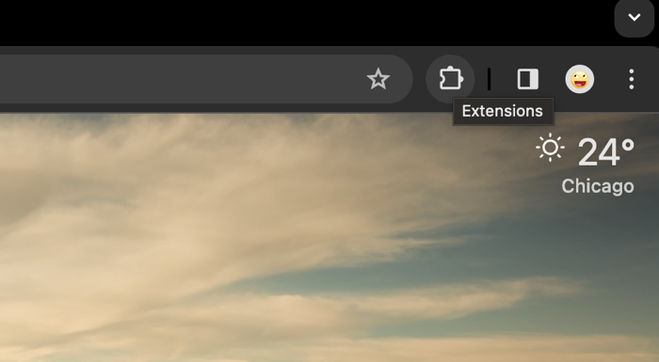

4. Click on “Manage Extensions”.

4. Choose “Load Unpacked” and select the unzipped folder.

5. Click on the puzzle icon and the “Ed Tech Leak Inspector” item.

6. Input information there.

To the Setting page: Puzzle icon – three dots next to the item – Options.

Choose accordingly. (Note: debug mode sends personal information to the backend; non-debug mode only stores personal information locally)

